**Ordinary Least Square (OLS)-**

It is an optimization technique. Optimization problems are mathematical problems that involve finding the best solution from a set of possible solution. These problems are formulated as maximization or minimization problems. In ML, optimization is used to find the best set of parameters for a model that minimizes the difference between the models predictions and the true values.

**Uses of optimization in machine learning-**

1. **In supervised learning**- optimization is used to find the parameters of a model that minimizes the difference between the model’s prediction and true for a given training dataset.
2. **In unsupervised learning-** In unsupervised learning and deep learning OLS regression is an optimization strategy that allows you to find a straight line that is as close as possible to your data points in a linear regression model.

**How OLS applies to linear regression-**

Linear regression is a family of algorithms employed in supervised ML tasks. Regression differs from classification because of the nature of the target variable. In classification, the target is a categorical value like yes or no.

Regression involves numerical, continuous values as a target. As a result the algorithm will be asked to predict a continuous number rather than a class or category. Imagine that you want to predict the price of a house based on some relative features, the output of your model will be the price, hence a continuous number.

**Regression tasks can be divided into two main groups-**

1. Those that only use one feature to predict the target.
2. Those that use more than one feature for that purpose.

For example- If we take an example of house price prediction. If we consider only its squared meters than we can use first case which uses only one feature.

But if you choose to predict price based on its squared meter, live ability and position that you are going to use second case which uses more than one feature. In simple case you can use simple linear regression and for second case you can use multiple linear regression.

**How to find OLS in simple linear regression model-**

In simple linear regression there is an assumption that there is a linear relationship between two variables and the equation for it is as follows-

$y_{i}=α+βx_{i}+ε_{i}$

$ε_{i}$ is the error term

$β$ represents the variation of the dependent variable when the independent variable has a unitary variation.

$α and β$ are the true but unobserved parameters of the regression. $α$ represents the value of our dependent variable when the independent one is equal to zero.

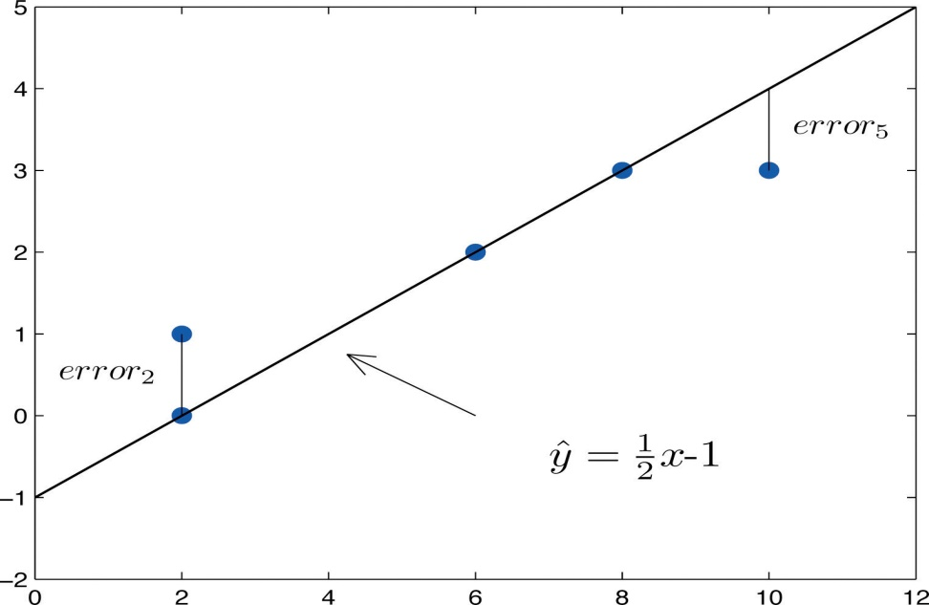

OLS seeks to minimize the sum of squared errors. We calculate the distance of each point from the best fir line, square it and sum all the squared errors together.

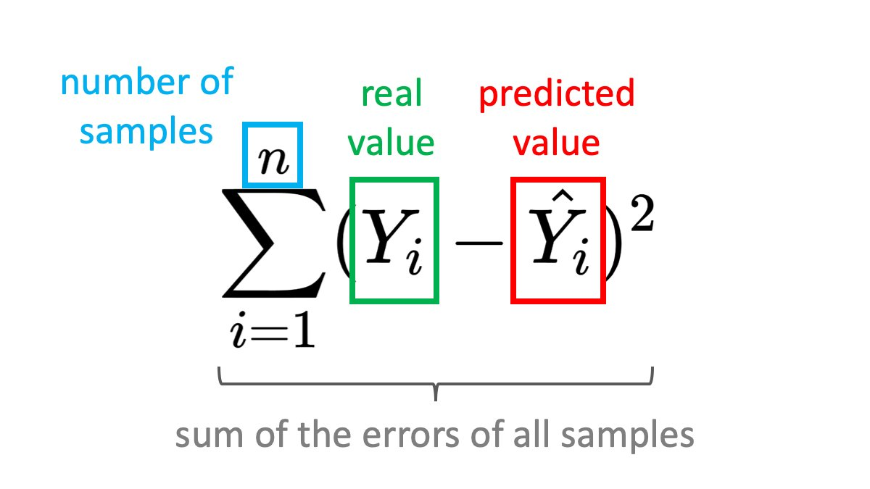

**Maximum likelihood-** Maximum likelihood estimation is a method that determines values for the parameters of a model. The parameter values are found such that they maximize the likelihood that the process described by the model produced the data that were actually observed.